Theme – GOD IS ALMIGHTY

Objective Summary

God will always do what He promises, and will rescue us in times of trouble. He can use even the smallest of people to do amazing things for His glory. This lesson aims to encourage children to trust God and believe in His promises.

Resources needed

Bibles
Paper to trace and colouring crayons (for the beginners & primaries)
Access to YouTube
Pencils/pens (older children)

Bible verses-

Judges 6:11-7:25
Amos 4:13,
Isaiah 47:4,
Memory verse -

“For the Lord almighty has purposed, and who can thwart Him? His hand is stretched out, and who can turn it back?” Isaiah 14:27

Lesson
Read as many Bible verses (see above) that a child can tolerate (the older the child, the more bible verses can be covered).

Introduction:
(Is anything too hard for the Lord?

What do you think ? Name some things that you know that God has done that would be too hard or even impossible for people.
Take a look at word “Almighty” on the poster below - today we’re talking about the truth that God is Almighty.
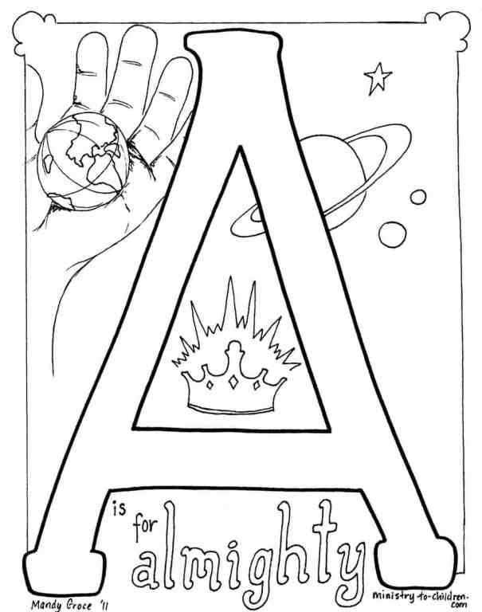

Discussion

Today our lesson will be from the book of Judges - Judges speak about the time period after God had led His people into the promised land, but that during this time they stopped following God and God judged them for the sin and then when they would repent God would send a judge (or leader) to rescue them. Gideon was one of the judges that God sent to rule over His people.

- God promised Gideon that He would defeat the Midianties using Gideon
- Gideon gathered up 32,00 men of Israel to go out and fight the Midianties.
- God didn’t want or need that many men to fight the battle. He was going to fight the battle for them. He didn’t want them to think that they were winning the battle in their own strength, He wanted them to know that the battle would be won in His power
- So God sent them down to the river to get a drink and He told Gideon to choose the men who lapped up water from the river like a dog….this was only 300 men. God told Gideon that He would win the battle for them with only these 300 men.
- Read Judges 7:15-25 – So God won the battle for them with only 300 men. They could see that they won only because God is all powerful….or ALMIGHTY.
ALMIGHTY = Having absolute power or all powerful
God saved the Israelites with only 300 men to show His power and to make sure that the Israelites knew that salvation was through God alone. God wanted to make sure that no one could boast in their own strength or think that they had fought the battle on their own. The same is true for us when we think about salvation.
Activity
Each student should write on a blank piece of paper the word ALMIGHTY then write or draw something to help them remember this attribute of God. They could write the definition for almighty or the memory verse or they could illustrate the verse or the story of Gideon or any of the other passages you read about God being almighty.

Prayer
Praise the almighty God for the way we saw Him rescue His people in this morning’s story and ultimately for the way we see Him rescue His people through the death of Jesus. In Jesus name we pray Amen

