Providence Sunday School Lesson Guide For all ages (May 3, 2020)

Theme – God's plan is simple. Just follow the directions.

Objective Summary

We often face problems in our life. Sometimes we are willing to try almost anything -- anything, that is, except what God's Word tells us to do. God's Word has the solution to all of life's problems, if we will just follow the directions.

i) To focus on the reading 2Kings 5:1-14
ii) To learn memory verse Luke 11:28 “Blessed are those who hear the word of God and obey it!”

Resources needed

Bibles
Paper to trace and colouring crayons (for the beginners & primaries)
Printed Activity sheets
Access to YouTube
Pencils/pens (older children)
Box of Jello mix (can be done at a later date)

Lesson

Introduction:
Think about how simple it is to accept God’s love. God offers us his love and forgiveness and what is asked of us is that we say yes. God’s Spirit then guides us, teaches us, helps us to have a good life and life ever after.
When making Jello all you need is the Jello Mix and water

How simple! You don't even have to cook it. Anyone could do that, couldn't they? Even you and I can handle this simple task. You know, there are many things in life that are really very simple. All we have to do is to learn to follow the directions.

In our Bible lesson today, we will hear about a man named Naaman who learned that even serious situations can sometimes have a simple solution. The problem is sometimes that simple solution requires us to be humble which can be the stumbling block but there are many blessings if we just follow the instructions.

Read and watch
2 Kings 5:1-14

Younger Children
https://www.youtube.com/watch?v=Py6dl-jGMkw

Older Children
https://www.youtube.com/watch?v=YYQ-z5DpI7o

Discussion

All ages but for the very youngest, just focus on the names of the main characters (Naaman, Elisha), the instruction of Elisha, and the result of Naaman carrying out the instruction.

- Who was Naaman?
- Naaman lived in the land of Syria and was the commander of the army for the king of Syria.
- He was a great man and a mighty warrior in the eyes of the king
- The king thought very highly of him because the Lord allowed him to win the battle against the Israelites.
- Naaman had everything going for him, but he had leprosy.

In bible times leprosy was an incurable disease. It was a horrible skin disease where the skin eats away at itself and leaves open wounds and scars. As the disease gets worse, people would lose their fingers and even their face would become deformed.

When Naaman and his soldiers had fought against the Israelites they captured many people and carried them back to Syria as slaves. One of these slaves was a young girl Naaman gave to his wife as a servant. This young girl knew God and knew that God had a plan for her even though she was taken away from her family. The servant girl must have felt sorry for Naaman because she told his wife about a prophet in Israel who could heal leprosy.

Naaman went with his horses and with his chariots, and stood at the door of the house of Elisha. Instead of going out to him Elisha sent a messenger to him, saying, ‘Go and wash in the Jordan seven times, and your flesh shall come again to you, and you shall be clean'.
Naaman became angry when he heard these instructions. He thought Elisha’s advice was too simple and insulting.
However his servants spoke to him, and said, “… if the prophet had asked you to do some great thing, wouldn’t you have done it? How much rather then, when he says to you, ‘Wash, and be clean? The servants encouraged Naaman to follow Elisha’s directions to see what would happen.
So Naaman went and washed in the river seven times and the sores on his skin were healed and he was clean.

For Seniors and Youth
Discuss some instructions of God that seem simple but yet we find difficult to do eg. Love your neighbour as yourself. Have a discussion about some very real life situations.
Learn Memory verse

“Blessed are those who hear the word of God and obey it!” Luke 11:28

Activities
See activities below and how about making Jello sometime this week!
Prayer
Heavenly Father, when we face life's problems, help us to be willing to follow the directions which you have given through the Holy Spirit and your Holy Word. In Jesus' name we pray. Amen.

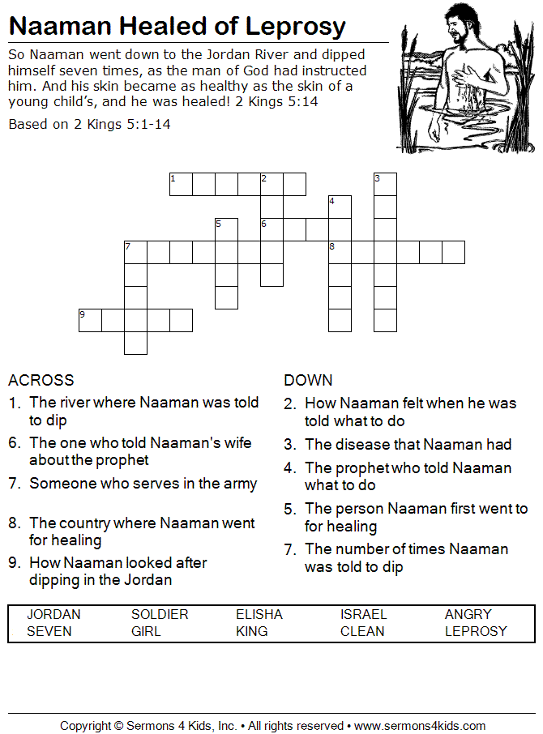
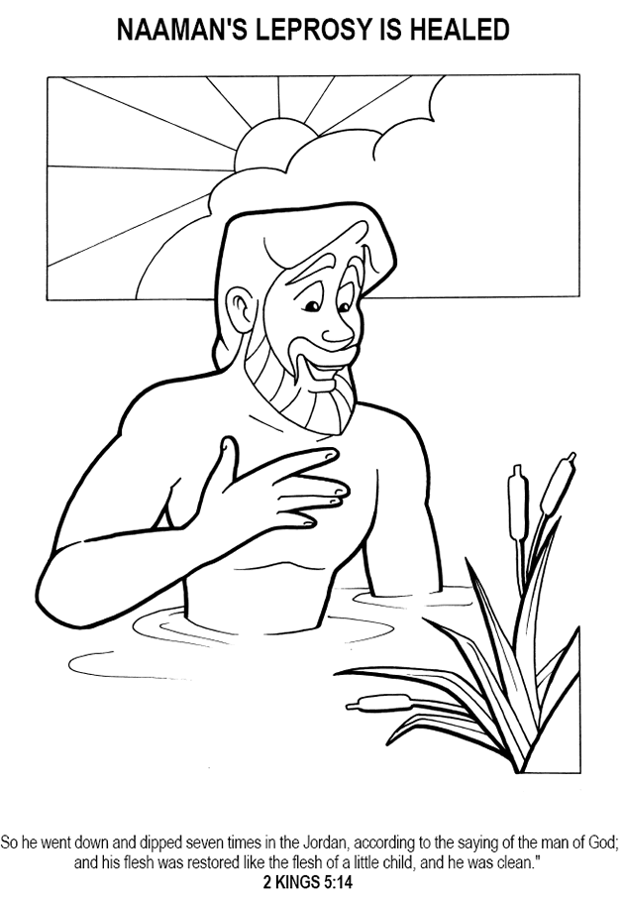

Namaan's Leprosy is Healed

Multiple Choice
