PARENTS PLEASE READ THROUGH FIRST SO THAT YOU CAN FLUENTLY WORK THROUGH WITH STUDENTS.
FOR ALL STUDENTS - BEGINNERS TO YOUTH

Theme – Jesus is alive!

Objective Summary

- To teach/remind the children the story of the Walk to Emmaus (Luke 24:13-34)
- To establish the fact of the resurrection of Jesus.
- To emphasise the importance of Scripture (for older children)
- To learn memory verse (younger children) Luke 24:34 “The Lord is Risen indeed”.
- To learn memory verse (older children) Luke 24:32 “Were not our hearts burning within us while he was talking to us on the road, while he was opening the scriptures to us?”

Resources needed
- Bibles
- Computer or phone to watch video
- Printed activity sheets if possible
- Paper for drawing/writing, crayons, pencils/pens

Lesson and Bible Readings
Bible Readings:
- Read Luke 24: 13-35 (It might be too long for the little ones unless the story can be found in a children’s bible. Please use video below.)

Watch the following YouTube videos:

- For Beginners and Primaries
https://www.youtube.com/watch?v=5ucK3U3nnOI

- Juniors, Seniors and Youth
https://www.youtube.com/watch?v=hw3Gk7c-Otg

- Gen J Video (complicated for the little ones but they might enjoy the familiar faces).
https://youtu.be/DRWmjK0E7PE (Full video premieres this Sunday at 9:30am after the youth service!)

Discussion:
Younger children Beginners and Primaries

- Let the children talk about the story. Let them put the story in their own words. Remind them about the beginning; middle and ending of the story (just fill in the gaps as they tell the story). (The younger the child the lesser the detail expected.)
Guide for Beginning, Middle and Ending
Beginning – Two followers of Jesus – Cleopas and another were walking on the road to a place called Emmaus talking about all the things that were happening. This other person joined them. It was Jesus but Cleopas and his friend did not recognise him.

Middle – Jesus asked them what they were talking about and they were surprised by the question. They told Jesus (who they thought was a stranger) about all the things that had happened recently – how Jesus had died and was buried in a tomb but that some women went to the tomb that morning and could not find Jesus’ body. Then Jesus explained to the 2 men lots of stuff that was in the bible to show why things had to happen the way they did.

Ending – When they got to Emmaus the two men invited Jesus in to stay with them because it had gotten late. They sat at the table to eat. Jesus took the bread and blessed it and broke it and gave it to them. Then they recognised that this person was the risen Jesus. Jesus then vanished. The men then went to Jerusalem and reported to the disciples what had happened.

- Allow children to memorise verse: “The Lord is Risen indeed” Luke 24:34

- Tell the children that one of the things this story shows is that Jesus rose from the dead.

For Juniors, Seniors and Youth

- Ask the following questions. (Students can have their bibles open)

- How many followers of Jesus were walking on the road? (2 – Cleopas and another)
- Where were they going? (To a village called Emmaus)
- Who joined them as they walked? (Jesus)
- Did they recognise him? (No)
- What did Jesus ask them? (What are you talking about?)
- Why were they surprised about Jesus’ question? (They thought it was surprising that this ‘stranger’ did not know what was happening?)
- What did Cleopas and his friend tell Jesus -who they still did not recognise? (The things that happened to Jesus – how he was crucified, how they had hoped Jesus was the one to redeem Israel and that some women had reported that Jesus had disappeared from the tomb.)
- What was Jesus’ response to them? (He had a bible study with them, he explained and interpreted scripture to them and explained why things had to happen the way they did)
- What happened when they reached to the village? (They invited Jesus into their home because it was late)
- What happened when they sat at the table? (Jesus took the bread, blessed it and broke it.)
- The scripture says, “then their eyes were opened”. What does that mean? (They realised that it was Jesus that was with them all along.)
- What happened next? (Jesus vanished)
- What did they say to each other – i.e. What is your memory verse? (Were not our hearts burning within us while he was talking to us on the road, while he was opening the scriptures to us?”)
- What did Cleopas and his friend do? (They went to Jerusalem and told them what had happened on the road and how Jesus had revealed himself to them.)

- Learn memory verse.
“Were not our hearts burning within us while he was talking to us on the road, while he was opening the scriptures to us?” Luke 24:32

- Ask the students why they think that this story was recorded by Luke. (One main reason was to show that Jesus did rise from the dead and Cleopas and his friend were primary witnesses of that fact. )
- For seniors and youth - have a discussion about what lesson the story provides for them individually. (You can refer to the lesson points in the Gen J video.)

- Ask the students to look at verses 25-27. Have a discussion about those verses and the fact that scripture though written over thousands of years by different persons inspired by God, is a unified story that point to Jesus Christ.

- Watch https://www.youtube.com/watch?v=ak06MSETeo4

Prayer
Dear Lord God, we praise you and thank you for all you do for us. Thank you that you provided stories like the Walk to Emmaus so that we can really know that you resurrected from the dead. Thank you that we have the freedom to read and study scripture. Lord just like you helped Cleopas and his friend to understand the scripture, guide us with the Holy Spirit to understand scripture more and more. Amen

Activities for Beginners and Primary:
1 Print or trace the below picture for colouring.

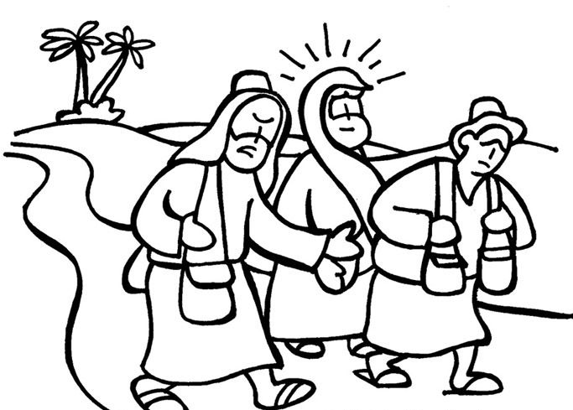
2. Activity for Junior and Seniors – please print if possible

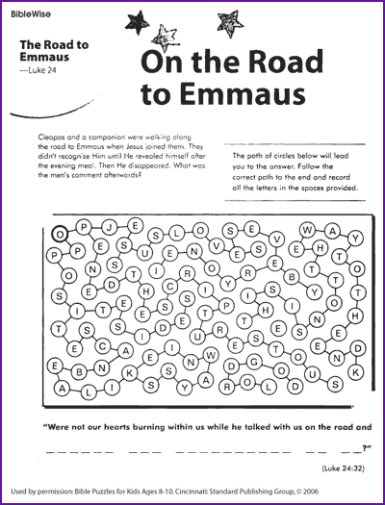

Translation used for above activity is from NIV

