Theme – Put Your Trust in God

Objective Summary

i)To focus on what the Bible teaches about trusting God to keep His promises.
ii) To learn memory verse Psalms 118:8 - [It is] better to trust in the LORD than to put confidence in man.
iii) To emphasise that we can trust God all of our lives just like Abraham did.

Resources needed

Bibles
Paper to trace and colouring crayons (for the beginners & primaries)
Access to YouTube
Pencils/pens (older children)

Bible verses

Genesis 17:19, Genesis 18:1-15, Psalm 116: 1 and 2 and Psalm 118: 8,

Memory verse -

Psalms 118:8 - [It is] better to trust in the LORD than to put confidence in man.

Lesson
Read as many Bible verses (see above) that child can tolerate (the older the child, the more bible verses can be covered).

Let us think about what it means to trust in someone or something. When we trust someone we believe that if they promise to do something then they will do it. You might have heard the phrase that promises are made to be broken. Sometimes people make promises to us and for some reason or the other they don’t keep them and sometimes you may even hear them say that promises are made to be broken.

On the other hand, God keeps promises. His promises are always kept. That is why it is better to put our trust in God than in man. Sometimes the promises are not fulfilled in the time we expect or even sometimes in the ways that we expect but God keeps them. The story of Abraham and Sarah teaches us about promises and trusting in the Lord always.

Watch:
https://www.youtube.com/watch?v=NdqrwGJYePQ

Discussion

Abraham and Sarah were elderly. Abraham was almost a hundred years old and his wife Sarah was almost ninety. It is not the norm for a woman that age to have children. But yet God had promised Sarah that she would have a son and that she would be the mother of nations. He had promised Abraham that he would be the father of a great nation and that his descendants would be like the stars in the sky.

In Genesis chapter 18 we read about how the promise became even more specific as God sent three men to Abraham and one of them told him that in nine months’ time Sarah would have a son.

- How do you think they felt when they were again told that they would have a child within a year?
- Why do you think Sarah laughed?
- How do you think they felt about God’s promise to them?

The Lord blessed Sarah and as He has promised she became pregnant and had a son and he was named Isaac. Isaac’s descendants are numerous. Did you know that Jesus is a descendant of Abraham and Isaac?

- This story demonstrates that God keeps his promises
- We have to trust in Him always
- God’s promise to Abraham was what is called a covenant. God made a promise to Abraham and Abraham made a promise to God that he and his descendants would serve Him.
- Trusting in God requires us to have faith, to pray to him and believe that he will fulfil His promises to us.
- We also have to think about what promises we can make to God.
- We can make a promise to serve him and be faithful to him.

Activity
- Learn memory verse Psalm 118:8
- See Activity sheets below

Closing: It is even more important that in this time of uncertainty we put our trust in the Lord. He is faithful and just and he will provide for us in ways we would never imagine. Some of us may feel hopeless because of what is happening around us. We hear about people being sick with corona virus. We are fearful that we or our loved ones could also become ill. You are encouraged to put your trust not in man but in the Lord.
Prayer
Dear God, you have been good to us. You have kept us safe and secure in this time. You have promised never to leave us and we trust that you will always be there for us. Even when times get rough you will be there to give us hope and you will be there to protect us and keep us safe. You will be there to fulfil your promise to us. Strengthen our faith Dear Lord so that we will trust in you wholly and completely. In Jesus name I pray. Amen.

Activity Sheet for Beginners

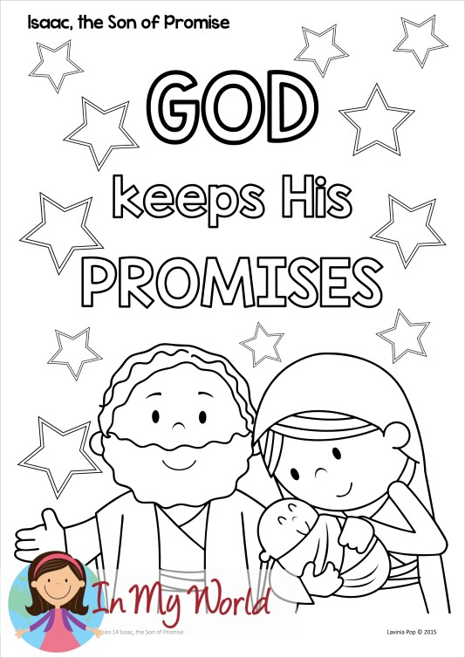

Activity Sheet for Primaries

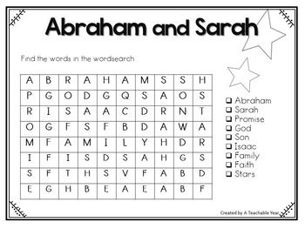

Activity Sheet for Older Groups
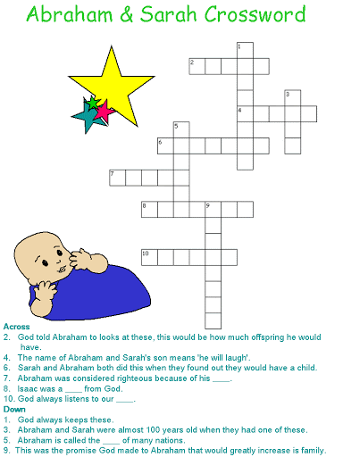

The puzzle below will require additional reading of Genesis Chapters 17, 18 and 21.
