INTROIT – COMBINED CHOIR (Congregation Standing

CALL TO WORSHIP (Congregation Standing)

Arise, shine; for your light has come! The glory of the Lord has risen upon you.
The Lord has arisen upon you,
His glory has appeared over you.
Nations shall come to his light,
and kings to the brightness of his dawn.

HYMN #63 VIP – Hark! The herald angels sing

OPENING PRAYER
THE ADVENT CANDLE LITURGY – led by the Goldson family

ARE WE THERE YET? - LOVE
Reader One: We light this candle. It seems a simple thing, lighting a candle, a quiet thing that I do alone, to provide something bright in the midst of all my darkness. But it doesn’t make that much difference. It doesn’t change the power of the night to bring doubt and fear and separation. It doesn’t make the world a better place, lighting a candle. Does it?
Reader Two: We light these candles. Because we have seen a light and we believe increasing that light does make a difference in the world around us. We light these candles because we want to be people of the light, who know a God who loved the world so much, this God chose to be born in a manger in the midst of the darkness. We light these candles as a sign of the light of the world that is coming into our darkness, and we sing with joy.
Reader One: We light the candles of Peace, Hope, Joy and Trust as our circle is complete. And we light the light of Love as the sign of Christ’s presence among us, no matter how dark it may seem.

(Light all four candles on the wreath and light the Christ candle in the centre)

Reader Two: The people who have walked in darkness have seen a great light. Glory to God in the highest heaven, and on earth let there be Love.

CAROL
Praise de Lawd! Shout fi joy!
Jesus born!
Angels sing loud on high,
Jesus born!
On dat morning so long ago,
In a stable so mean and low,
Jesus Christ, Son of God,
He was born!

Christmas morning soon here,
Shout fi joy!
Children sing loud and clear –
It’s a boy!
Ring de bells, blow de trumpet loud,
Sing a song, come on strong and proud;
Spread de word, tell de world –
Jesus born!
Hallelujah to God!
Jesus born!
One big star shine like mad
When Him born!
And God’s glory was everywhere
When He sent us His Son to share,
Glory, glory to God!
Jesus born!

Praise de Lawd! Shout fi joy!
Jesus born!
Angels sing loud on high,
Jesus born!
On dat morning so long ago,
In a stable so mean and low,
Jesus Christ, Son of God,
He was born! (Christine Soares)

WELCOME AND NOTICES - Steward on Duty
TITHES AND OFFERINGS
THE COMBINED CHOIR ANTHEM
MINISTRY OF THE WORD

THE COLLECT - Almighty God, you have given us your only-begotten Son to take our nature upon him and as at this time to be born of a pure virgin: grant that we, who have been born again and made your children by adoption and grace, may daily be renewed by your Holy Spirit; through Jesus Christ your Son our Lord. Amen.
OLD TESTAMENT READING, Isaiah 62: 6 - 12
RESPONSIVE READING, PSALM 97 ¹ The Lord is king! Let the earth rejoice;
let the many coastlands be glad!
² Clouds and thick darkness are all around him;
righteousness and justice are the foundation of his throne.
³ Fire goes before him,
and consumes his adversaries on every side.
⁴ His lightnings light up the world;
the earth sees and trembles.
⁵ The mountains melt like wax before the Lord,
before the Lord of all the earth. ⁶ The heavens proclaim his righteousness;
and all the peoples behold his glory.
⁷ All worshipers of images are put to shame,
those who make their boast in worthless idols;
all gods bow down before him.
⁸ Zion hears and is glad,
and the towns of Judah rejoice,
because of your judgments, O God.
⁹ For you, O Lord, are most high over all the earth;
you are exalted far above all gods. ¹⁰ The Lord loves those who hate^{[b]} evil;
he guards the lives of his faithful;
he rescues them from the hand of the wicked.
¹¹ Light dawns for the righteous,
and joy for the upright in heart.
¹² Rejoice in the Lord, O you righteous,
and give thanks to his holy name! Glory be to the Father and to the Son and to the Holy Spirit As it was in the beginning is now and ever shall be, world without end. Amen.
EPISTLE READING, Philippians 2: 5-11
HYMN #64 VIP – He was born on Christmas day
GOSPEL READING, Luke 2: 1 - 20
SELECTION “Today a child is born” – Carolyn and Christopher Sinclair-McCalla
MESSAGE
DANCE SELECTIION – “Light of the World”
PRAYERS FOLLOWED BY THE LORD’S PRAYER
HYMN #66 VIP – O come all ye faithful
BENEDICTION
CHRISTMAS WISHES

THE METHODIST CHURCH IN THE CARIBBEAN AND THE AMERICAS- JAMAICA DISTRICT PROVIDENCE CIRCUIT
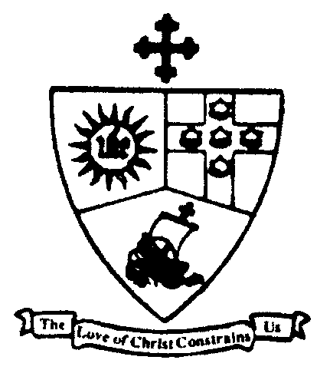

District Theme:

“SPREADING SCRIPTURAL HOLINESS TO REFORM THE NATION

… BEGINNING WITH ME!”

DISTRICT PRESIDENT
Bishop Christine Gooden-Benguche

CIRCUIT SUPERINTENDENT
Rev’d Dr. George Mulrain

PROVIDENCE METHODIST CHURCH
Wednesday December 25, 2019
THE FESTIVAL OF THE NATIVITY
DIVINE WORSHIP
6:00 a.m.
PREACHER
Rev. Dr George Mulrain
ORGANIST

STEWARDS ON DUTY

