Theme – Let your light Shine

Objective Summary
To show children that they are capable of doing good to others, no matter how small their service may be. God calls us to love Him through loving others, and we can do this in small ways every day.

i) To focus on the reading Matthew 5:14-16
ii) To learn memory verse Matthew 5:16
iii) To emphasise that Jesus’ light can shine through us.

Resources needed

Bibles
Paper to trace and colouring crayons (for the beginners & primaries)
Access to YouTube
Pencils/pens (older children)
A lamp

Memory verse

Let your light shine before others, so that they may see your good works and give glory to your Father in heaven. Matthew 5:16

Lesson

Introduction:
The Bible tells us that we should let our light shine so that people will see our good works and praise our heavenly Father.
Sing the following chorus:
"This little light of mine, I'm gonna let it shine!"
"Hide it under a bushel? No, I'm gonna let it shine."
"Won't let Satan (blow) it out, I'm gonna let it shine."
You know Jesus talked about light…….In Matt 5:14-16, Jesus said….. "You are the light of the world. A city that is set on a hill cannot be hid. Neither do people light a lamp and put it under a bushel, instead they put it on its stand, and it gives light to everyone in the house. Let your light so shine before men, that they may see your good works, and glorify your Father which is in heaven."

Discussion

When Jesus told us we are the light of the world, He was giving us a picture of who we are supposed to be. We are to be Christians everywhere we go. We should act in such a way, that others see Jesus in us and because of what they see they glorify God.

Think about the lights we have in our homes, whether a light on the wall or a lamp that we plug in. Both of these types of light comes with a switch we can turn them on and off easily. (Parents with toddlers can explain this by turning on and off the light switch)

- As Christians, do we turn our lights on and off as we please?
- If we want to act like the cool kids around us for a while, do we just turn our light off and act like the world?
- If we do not want to talk to that person sitting all alone on the playground, do we just turn off our light and just walk pass them?
- When we don't stick up for someone that others are making fun of, we turn off our light
- Then when we feel like doing something for Jesus, we turn our lights back on again?
- When we decide to help someone pick up all their papers, they just dropped, we turn it back on again?
- When we are at church, we turn the light back on.
When we act like the world, like people who don't know Jesus…..the world thinks we're just like them. Then when we decide to turn on our light, the world sees us as a fake, a phony.
When we switch our light off we knowingly and willingly choosing to sin. We are not doing what Jesus told us to do. Sin brings darkness instead of light. Remember, Jesus said we are not to put our lamp under a basket and hide it.
The next time you think about hiding your Christian faith, remember Jesus told us to let our light shine so that others see our good works so that our Father would be glorified.

Prayer
Dear Lord, thank you for sending Jesus to be the Light of the World. May we lift him up and let his light shine through us. Amen.

Let Your Light Shine
Coloring Page
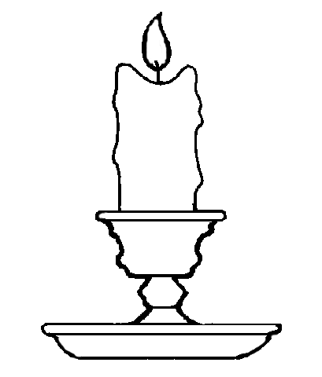
Let your light shine before men, that they may see your good deeds and praise your Father in heaven.
Matthew 5:16

