Sunday School Lesson May 10, 2020
Objective:
1. Children should show that they understand what it means to honor their mother
2. Children should be able to demonstrate an attitude of appreciation toward their mother by writing a “what I like about you” letter (Juniors & Seniors)
3. Children should learn memory verse Ephesians 6:1 “Children, obey your parents in the Lord, for this is right.”
Introduction: How many of you told your Mom / guardian that you love her this morning?
If you have not yet told her “I love you” already, Today, of all days, you need to say it. Today is Mother’s Day, and it’s a day set aside to honor Mothers. Mothers are a blessing! They love us, take care of us and teach us good things. We may appreciate it more on some days than others but we are to always honor and respect our mothers. God promises us a blessing when we honor and respect them.
Bible Lesson:
There’s a beautiful story about a mother and child in the Old Testament. It is found in RUTH 1:6-17. The child wasn’t even the mother’s child; she was her daughter-in-law. But this story gives us a good example to follow. It shows us how to love our mothers the way God wants us to.
MAIN POINT OF THE STORY:
Naomi had lost everything, her husband and her two boys. She had no choice but to go home and hope that someone in her family would take pity on her. She didn’t want Ruth to suffer with her, and she selflessly told Ruth to go home.
Ruth refused. Ruth loved Naomi like a mother. She promised to take care of Naomi. She would provide for them both, and she would worship God with her adopted mother. Ruth showed Naomi the same selfless love Naomi had shown her. She followed God’s command, to love and honor her mother.
How should we love, honour and respect our mothers and guardians?
- First, we should be thankful to God for our mothers and our guardians
- God also wants us to have the right attitude towards parents
- We should listen to them and learn from them
- We must be obedient
- We must respect them
- We should do the things they ask us to do
- We must always think highly of our mothers and guardians
- We must always keep them in in a special place in our hearts
- We must always love our parents even when we think they are not perfect, even parents need Jesus to forgive them
Remember that God is happy when we love our mothers and guardians, they are a gift from GOD!!
Points to remember:
Moms do so much for us, we simply don’t have time to list it all. They teach us how to sit up, roll over, stand up, walk, talk, feed ourselves, and dress ourselves. They teach us to share with others. They provide us with food and clothing and medicine and toys, and sometimes most important of all - those loving hugs when we need it.
Moms also have the most important job of all: teaching their children to follow Christ. If you’re doing this lesson this morning, it means you have parents that take God’s commands to teach children to love God seriously. More than anything, they want you to become people who love God and love others. They parent because they love. God wants us to love them in return.
MEMORY VERSE:
“Children, obey your parents in the Lord, for this is right.” Ephesians 6:1
BEGINNERS AND PRIMARIES: Parents please read the memory verse aloud for these children and help them to memorize the verse. Each time you repeat, leave out one word. See if they can tell you what word you left out.
Activity:
Parents can help children to find the missing word for each sentence (words are given below)
I like it when you _ _ _ _ to me
I like it when you _ _ _ _ me when I am hurt
I like it when you _ _ _ me
I like it when you _ _ _ _ for me at bedtime
{pray, help, read, hug}
(2) Colour mother’s day card for Mother
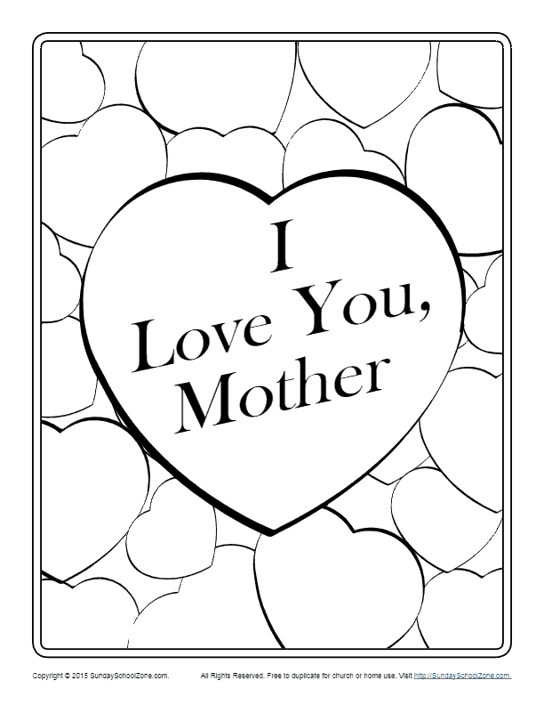

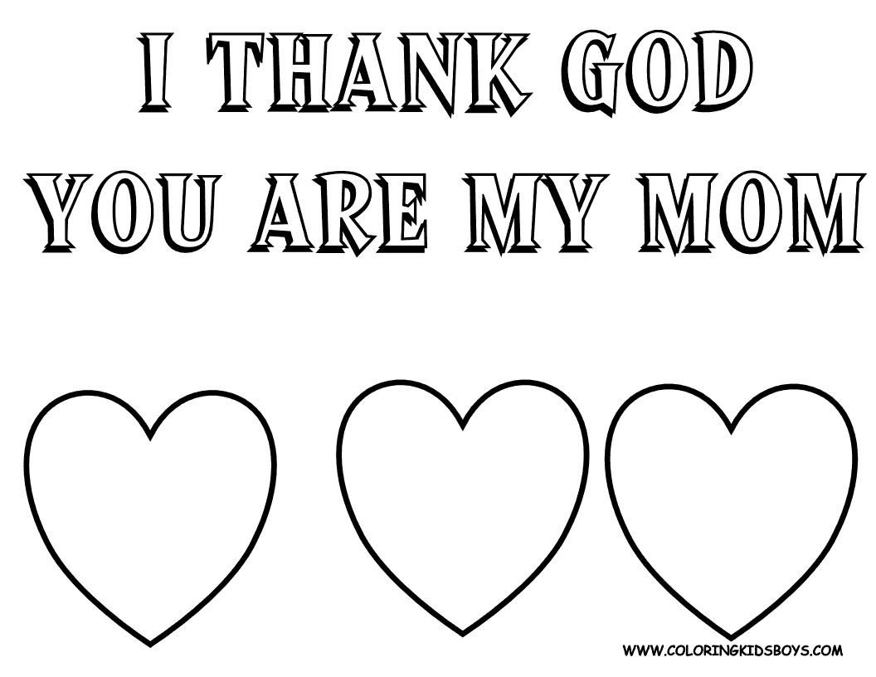

Juniors & upwards:
Children could write a simple letter to mother saying what they like about her
Moms are special ladies. They are a gift from God, and they will always be there for us. Let Mom know you love her every day. In words and in actions, let’s all remember to say “I love you” every day of the year!
Mothers Day Video
The Providence Sunday School Mothers’ Day video can be watched at (Anna Kay please insert link)

