PARENTS PLEASE READ THROUGH FIRST SO THAT YOU CAN WORK THROUGH WITH CHILDREN. EVEN THOUGH SCRIPT IS GIVEN, IT REALLY IS JUST TO GUIDE DISCUSSION. PLEASE FORGIVE ANY ERRORS.

FOR BEGINNES PRIMARIES AND JUNIORS

Theme – Jesus, dies and comes back to life because of His love for us.

Objective Summary

- To teach the children the story of death and resurrection of Jesus.
- To establish the fact of the resurrection of Jesus and its significance for us.
- To teach the love of Jesus for the world.
- To learn memory verse John 15 v 13. “Greater love has no man than this, that a man lay down His life for His friends”

Resources needed
- Bibles
- Computer or phone to watch video
- Paper for drawing/writing, crayons, pencils/pens

Lesson and Bible Readings
Bible Readings:
- (Matthew27:32-50)
- (John 20; 1-18)
(If the readings are too long for little ones they may watch videos instead)

Watch the following YouTube videos

The Crucifixion (watch up to 3:06)
https://www.youtube.com/watch?v=Y3UKd6LQKng

The empty Tomb
https://www.youtube.com/watch?v=xe50_LaJgWE

Discussion:
- Get the children to talk about the crucifixion of Jesus and His resurrection. They should say how they feel.
- Let them talk about times when they have been unfairly punished or hurt and how they felt.
- Point them to the prayer that Jesus prayed from the cross. “Father forgive them for they know not what they do” (Luke23 v 34)
- Let the children know that the way Jesus behaved can help them when they are unfairly treated.

Note to parents:
It may be tricky to have a conversation about the death and resurrection of Jesus without frightening especially the very young children as they may not have a full understanding of death. Especially, during these times when death from crime and the COVID 19 Virus is very much in the news, we need to be sensitive to their emotions. Try to answer any question they may have with assuring tones and allow them to express their feelings (even if it feels like they are going off point.

Prayer
Let the children say this prayer:
Dear Lord God, we praise you and thank you for bringing Jesus back to life. Please help us to become more like Him that we will go to live with Him forever when we die. We also pray for the people who hurt us and ask you to forgive them.

Activities for Beginners and Primary:
1 Let children name, draw and colour the people they learnt about in the Bible readings/video.

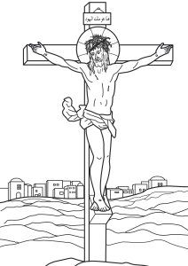

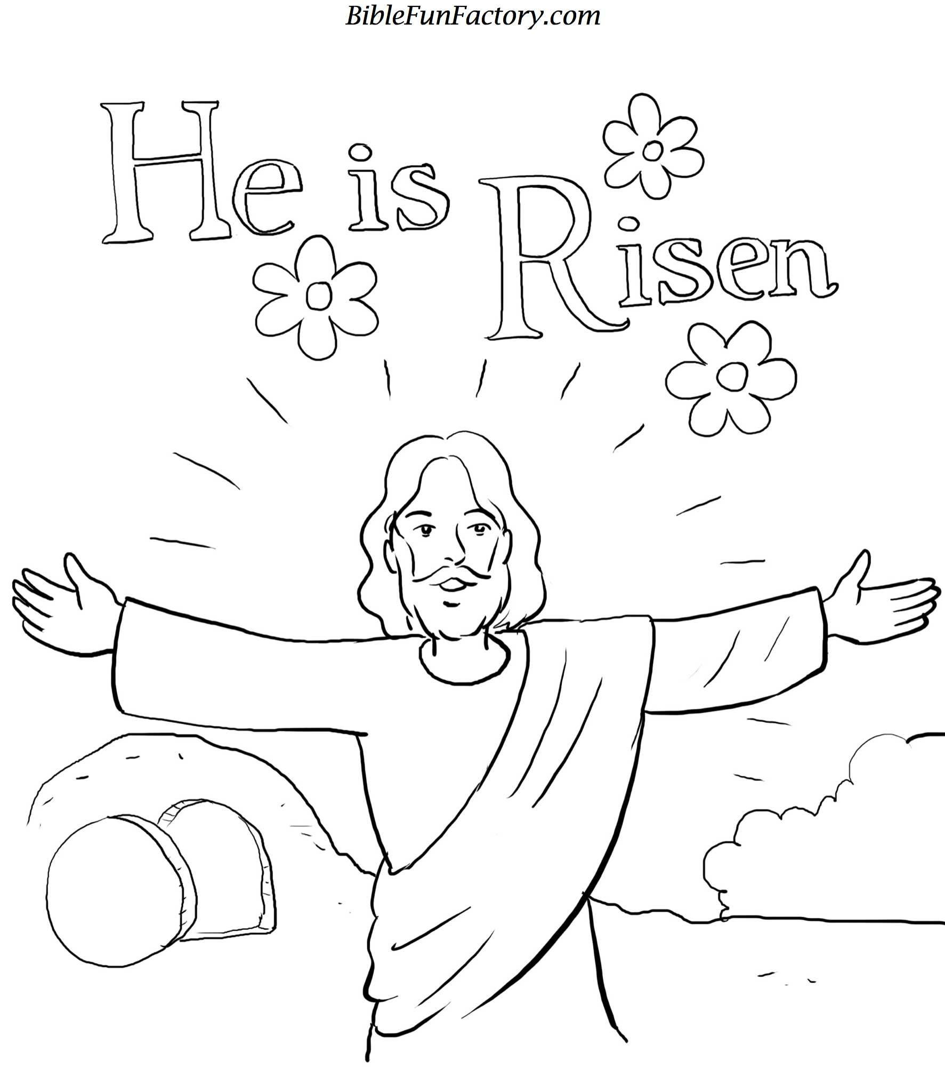

Activity for Juniors (Can be done orally)
Quiz:
- How was Jesus treated by the people when He was on the cross
- How did Jesus respond to the people when He was on the cross.
- On which day of the week did Jesus rise from the tomb in which his body had been placed?
- Who was the first person to reach the tomb?
- What did he/she see at the tomb?
- Can you name the other persons who also went to the tomb?
- What happened when they were still looking to find the body of Jesus?
- Say what happened to Jesus’ body.
- Tell how Jesus appeared to His disciples.
- How did the disciples feel when Jesus appeared to them?

