THEME : It’s stormy out there! Keep your eyes on Jesus
Please sit with your household – from the young to the old and have discussion, learn and have fun!
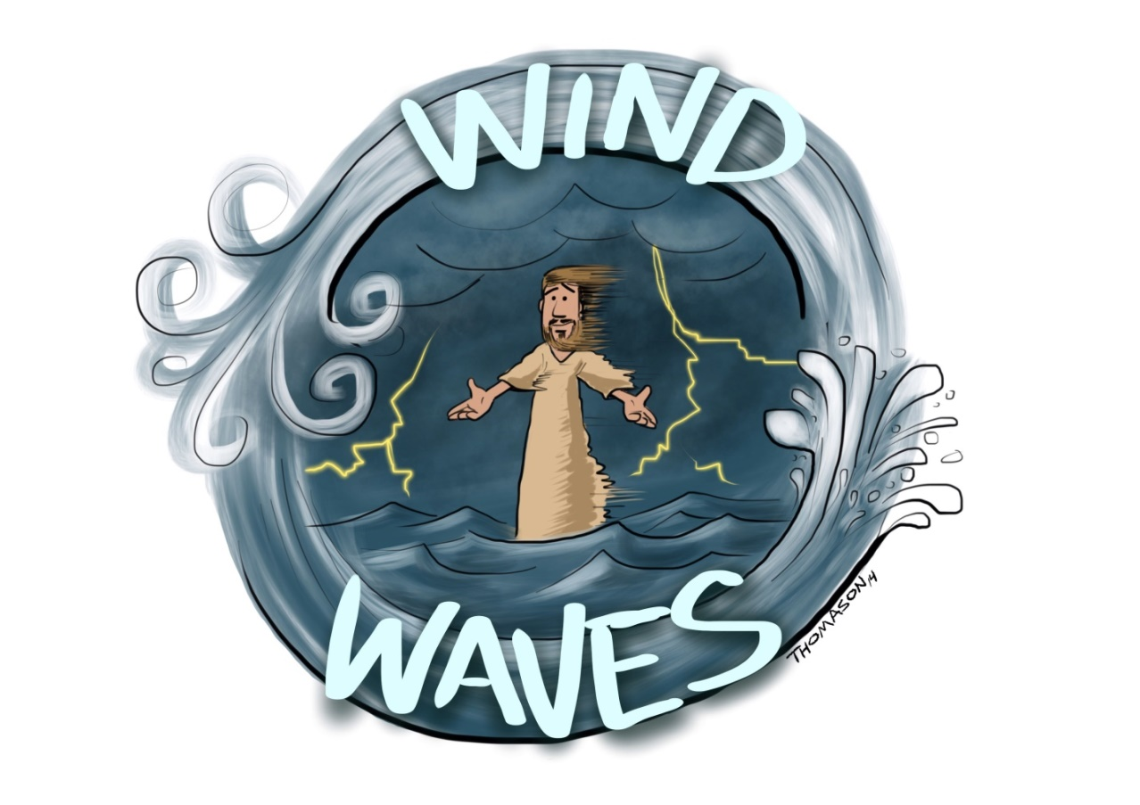
A little bit of Praise - Enjoy this song:
https://www.youtube.com/watch?v=WuODF9Kbgnw
Read Matthew 14: 22-33
- Older Children can click on following for reading
https://www.biblegateway.com/passage/?search=Matthew+14%3A22-33&version=NRSV

- Younger children can click on following for reading and video
Reading – https://www.biblegateway.com/passage/?search=Matthew+14%3A22-33&version=CEV
Story video - https://www.youtube.com/watch?v=oVy9HGr3Qig

Memory Verse
- Younger Children: Matthew 14:27
“[Jesus said], Take heart, it is I; do not be afraid.”

- Older Children:
Deuteronomy 31:6 - Be strong and bold; have no fear or dread of them, because it is the Lord your God who goes with you; he will not fail you or forsake you.”

Quiz Time
Choose questions that are age appropriate for your child.
After children have read and/or watched video have them answer the following questions. (Scroll down to see answers).
- Where did Jesus go to pray?
- Where did the disciples go?
- What happened in the evening?
- What did Jesus do early in the morning?
- The disciples saw something coming towards them, how were they feeling?
- What did they call out in fear?
- What was Jesus’ reply?
- What did Peter say?
- What did Jesus say to Peter?
- What did Peter do?
- What happened to Peter when he noticed the strong winds?
- What did Peter cry out when he began to sink?
- What did Jesus do after Peter cried out to him?
- What happened to the wind when Jesus got into the boat?
- What did the disciples do when Jesus got into the boat?

Discussion
Sometimes life is stormy. What is “stormy” in your life today? Jesus is there with us in the storm. But if we just think about the bad things happening around us, we will get afraid and even “sink”. (You can talk about COVID and school, or other personal things that might be happening in the family). This story about Jesus and Peter walking on the water tells us that when we listen and obey Jesus, we can do things that are difficult even when life is stormy. And when life gets too rough and we feel like we cannot continue doing those hard things that we know is right, we can call out to Jesus and say, “Lord, Save me.” Jesus will help us. He is there to calm the storms that we are in.
Older Children can continue to talk about these 4 lessons of the story:
- If Jesus says you can do it, then you can. (Think about your own examples or talk about other persons experiences )
- Sometimes you need to “step out of the boat” (Give examples of what that might mean)
- When you focus on the winds and wave you will sink
- When you take Jesus’ hand, you will not sink
- Watch this testimony of someone who went through storms and who at times felt he was sinking but chose God - https://youtu.be/fNOCaSzlrIM

Close Discussion with this song
https://www.youtube.com/watch?v=FKG68jp2cKo&app=desktop

Activities – Scroll down for activities. Choose appropriate for age.

Prayer – Encourage children to pray in their own words about the things that were raised in the discussion and to thank Jesus that He is with them in the tough times and ask Jesus to help them get through the rough times.

Answers to above questions
- Jesus went up the mountain to pray.
- The disciples got into the boat.
- A storm came and the boat was battered by waves. The boat drifted far away from the land.
- Jesus walked on the water towards the boat.
- The disciples felt frightened.
- “It’s a ghost!”
- Jesus replied, “Take heart, it is I; do not be afraid.”
- Peter said, “Lord if it is you, command me to come to you on the water.”
- Jesus said, “Come”.
- Peter got out of the boat and walked towards Jesus.
- Peter began to sink.
- “Lord, Save me”
- Jesus reached out his hand and caught Peter saying, “You of little faith, why did you doubt?”
- The wind stopped
- The disciples worshipped Jesus saying, “Truly you are the Son of God

*Opening Picture and concept from https://www.stevethomason.net/2011/08/08/facing-storms-a-sermon-on-matthew-1422-33/

